Made By: Laiba Jawaid
Week 1: Database Setup
Step 1: Install PostgreSQL
Download and install PostgreSQL from the official website.
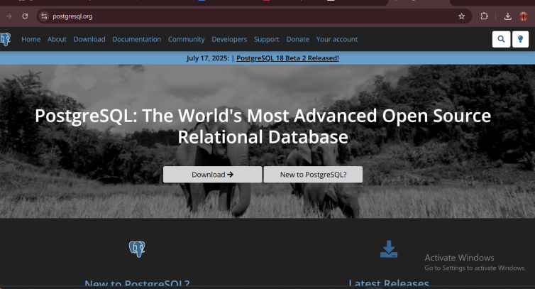
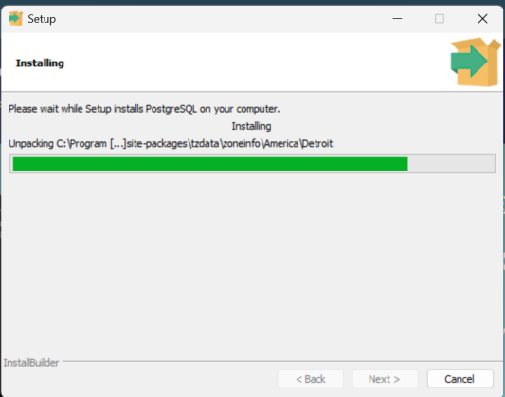
During installation, set up a username and password.
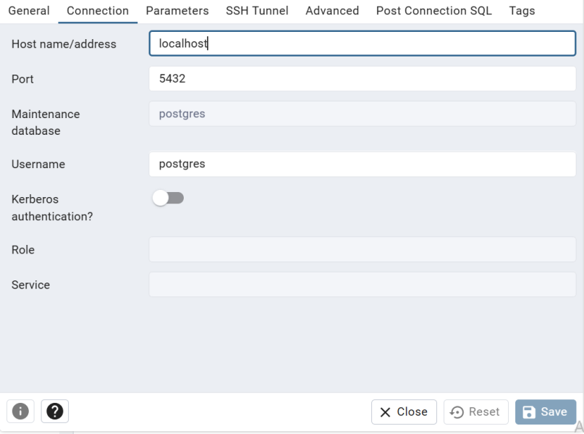

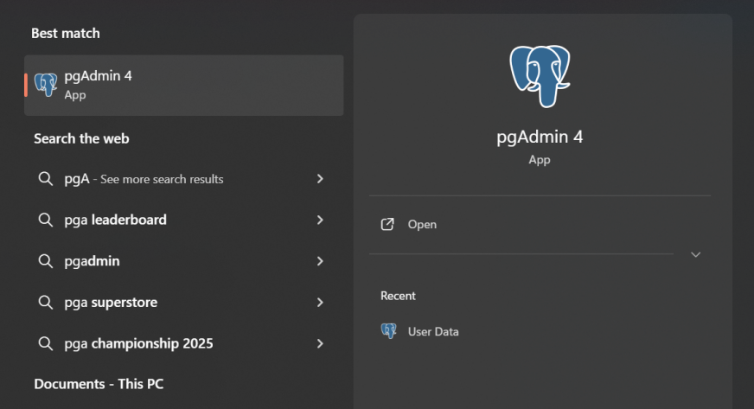
Ensure that pgAdmin (the database management tool) is installed.

Verify the installation by opening pgAdmin or using the terminal.
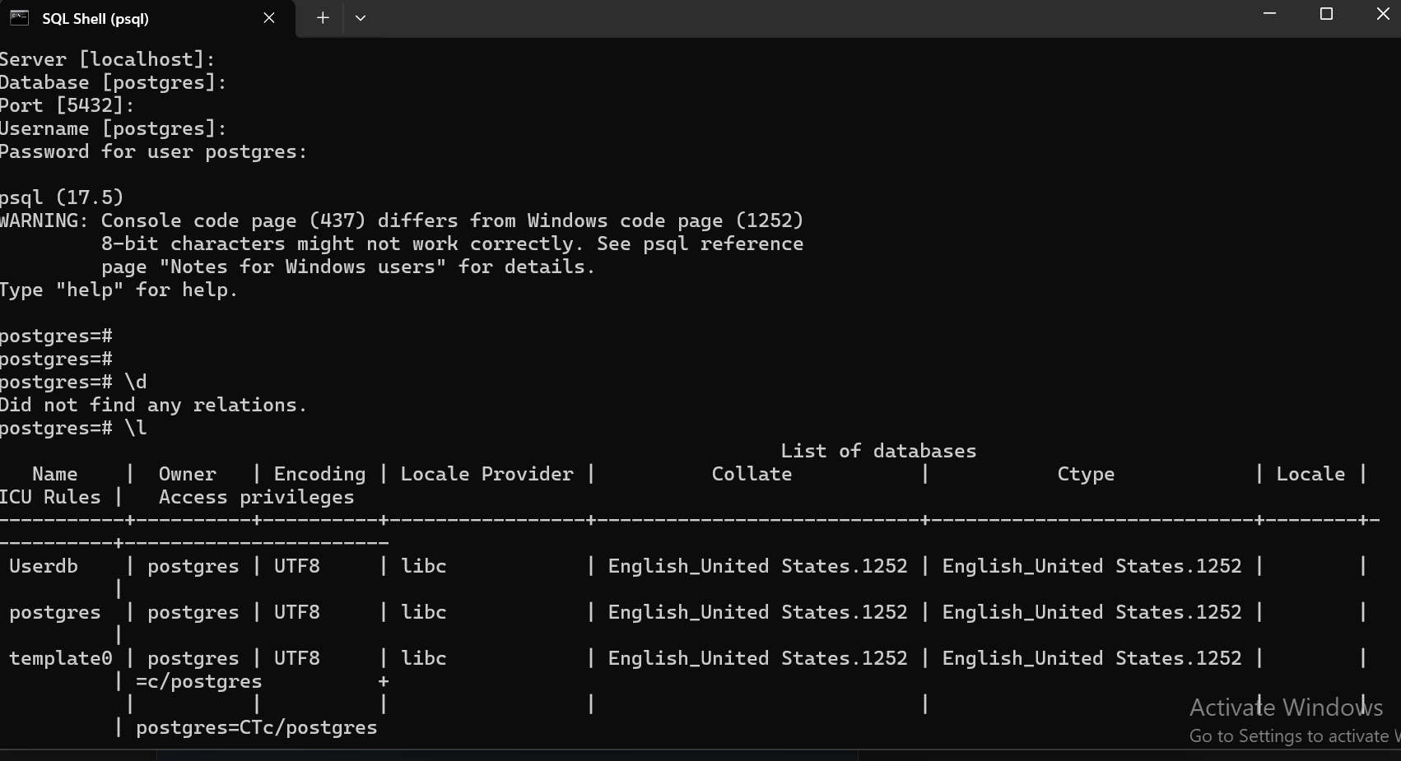

Step 2: Create a New Database
Open pgAdmin or the PostgreSQL terminal.
Create a new database and connect to it.
Look up how to create a database in PostgreSQL and connect to it.
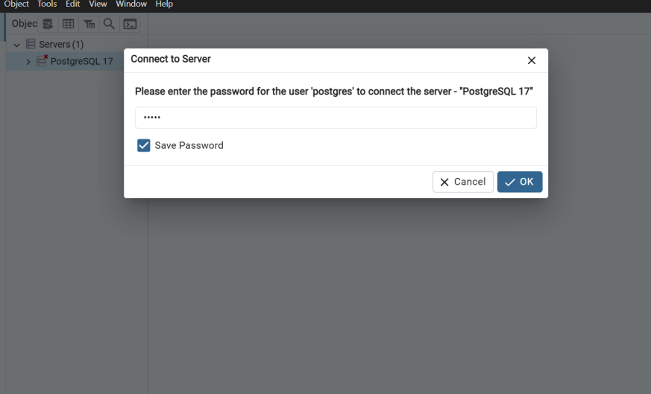

Step 3: Load a Dataset into PostgreSQL
There are two ways to import data:
Explore how to import a CSV file into PostgreSQL using both methods.


Using SQL Queries – Best for large datasets.

Using pgAdmin – A manual, step-by-step import process.
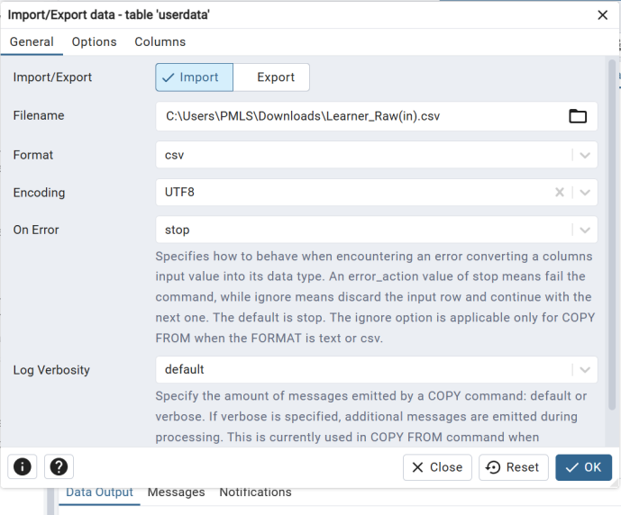

Step 4: Verify Data Import
Run simple queries to check if your data is successfully stored.
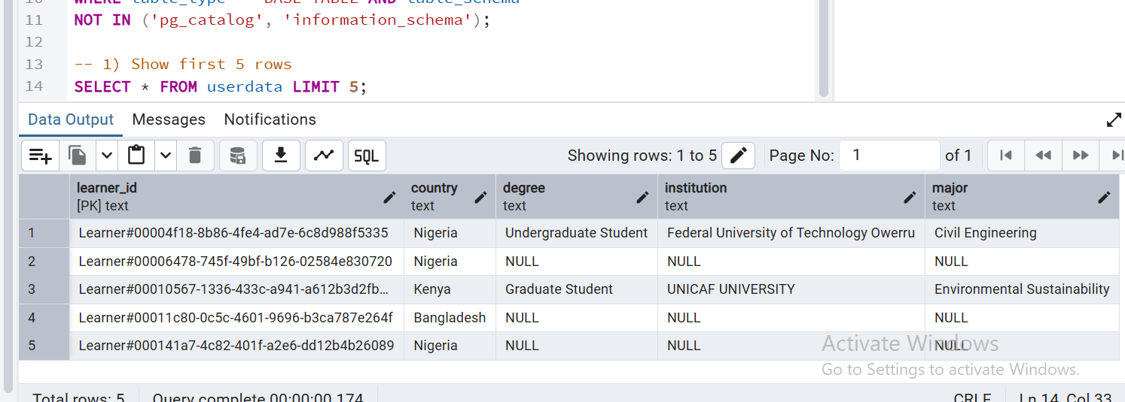

Confirm the total number of records in the table.
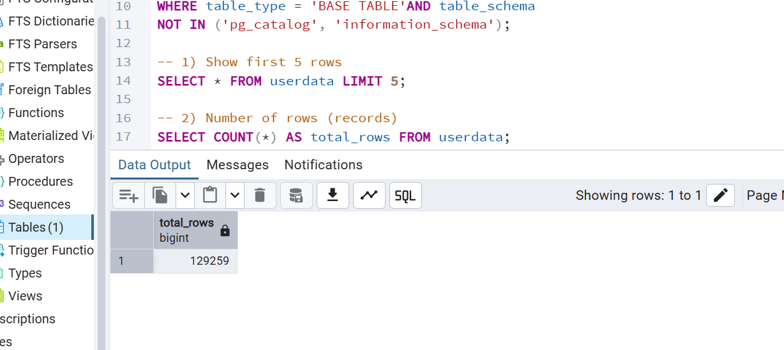

Find out how to run basic queries in PostgreSQL to check your data.
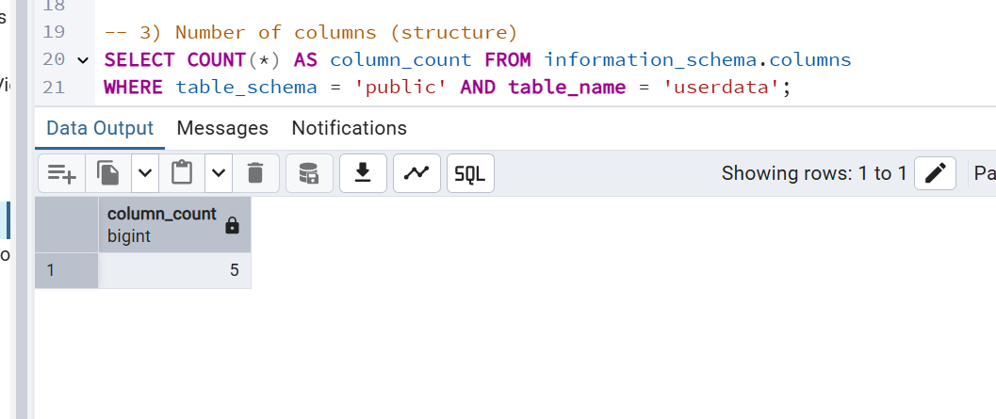

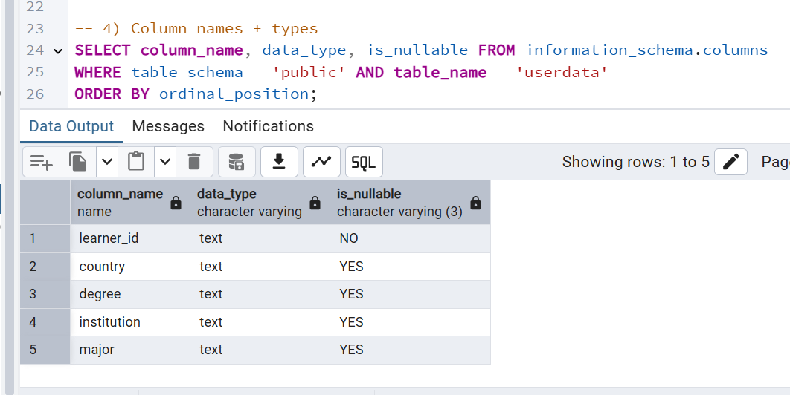

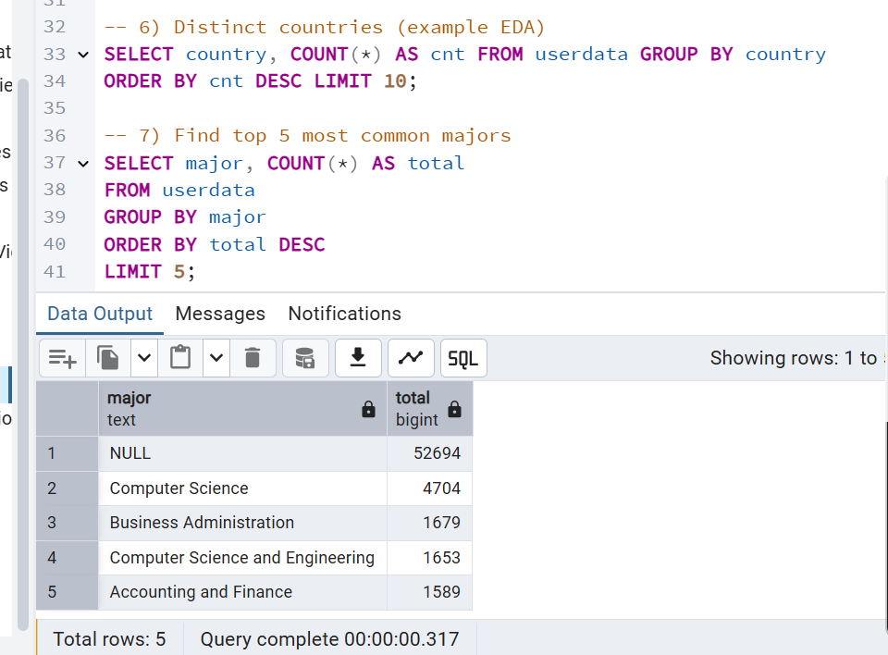

Made By: Laiba Jawaid
Week 1- EDA Report :

EDA Analysis- Missing by Mr. Abdul Kadar

Step 5: Visualize Data Trends
Use graphs like histograms, line charts, and box plots to identify patterns.

- Column Chart to Identify Learners by Top 10 Institutes:
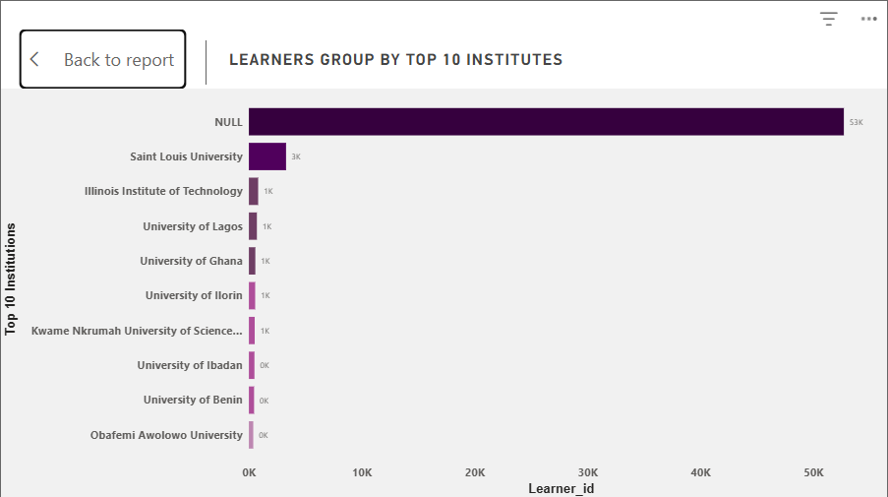

- Pie Chart showing Complete Vs. Incomplete Records in Dataset:
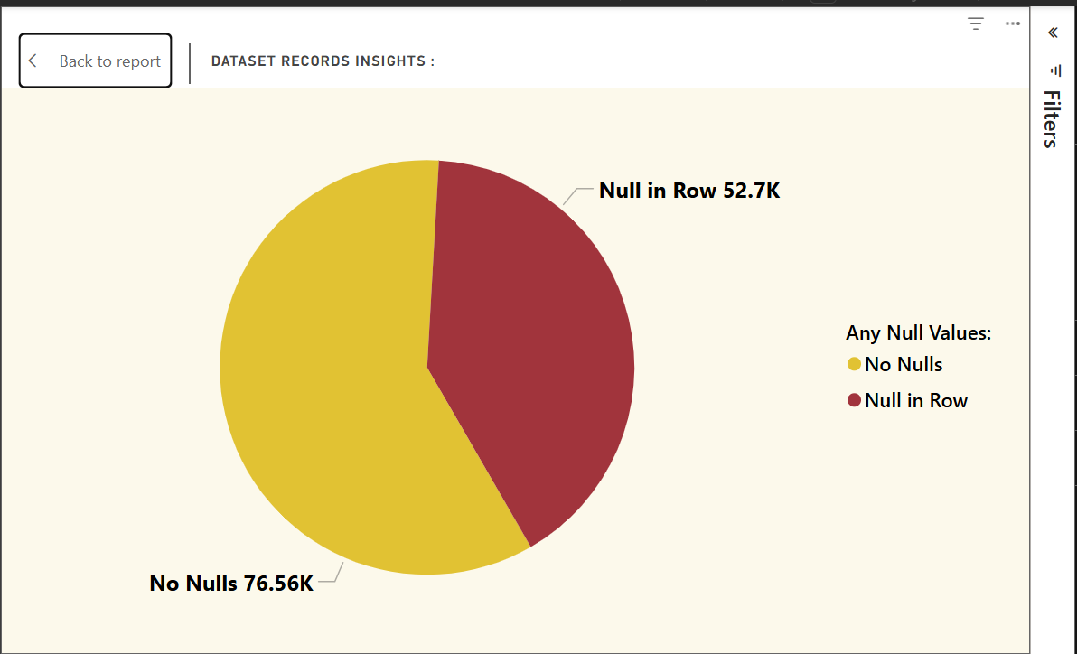

- Donut Chart to identify Learners by Top Countries:
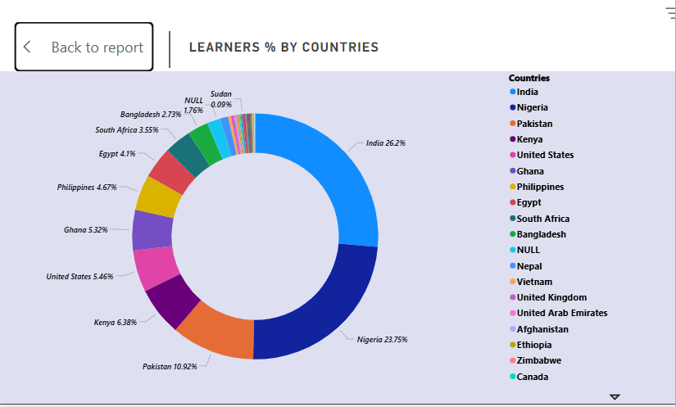
- Clustered Chart showing No. Of Learners with Degree:
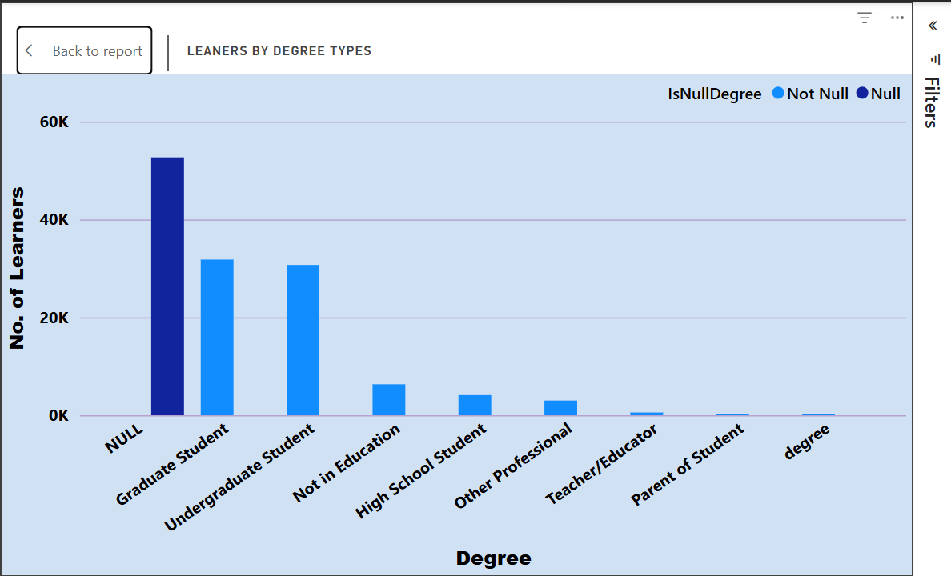

- Stacked chart for degree insights for each country:
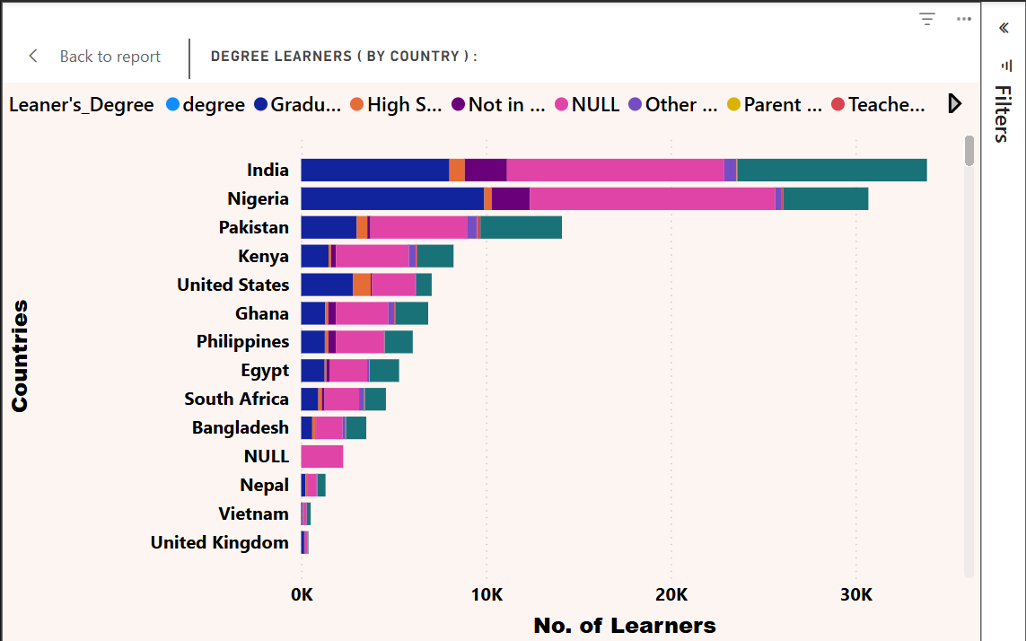

Key

Findings Summary :
- Data Completeness: Significant missing data across all fields
- Geographic Distribution: Heavy concentration in specific countries (India, Nigeria, Pakistan)
- Popular Fields: STEM fields dominate, especially Computer Science and Engineering
- Data Quality Issues: Inconsistent formatting, potential duplicates in institution names
- Sample Size: 129k+ rows are adequate for exploratory analysis but may not capture rare patterns
- Next Steps
- Data Cleaning: Standardize country names, institution names
- Categorization: Group similar majors into broader categories

( "This report was completed by Laiba ( laibajawaid77@gmail.com ), as Mr. Abdul kadar( talhaviacom8@gmail.com ) has not contributed in this report for any work yet." )

EDA OF OPPORTUNITY DATASET

Understand the Dataset

Step 1: Understand the Dataset
- View the first few rows to get an overview of the data.
- Check column names, data types, and the total number of records.
Research how to inspect a table’s structure and data in PostgreSQL.

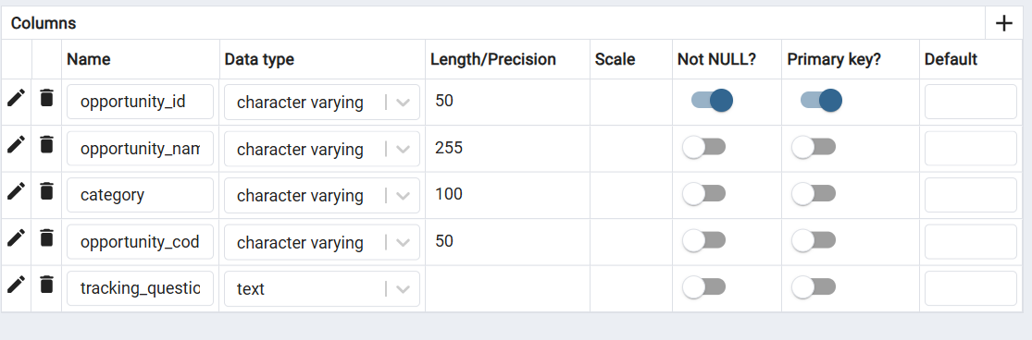
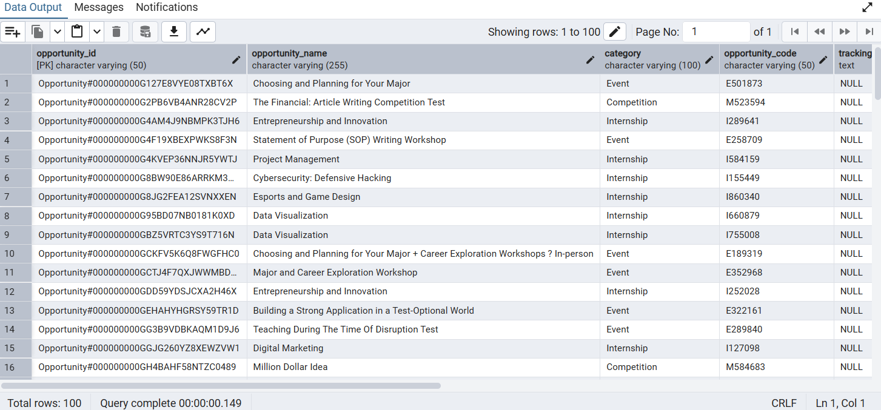

Summarize the Data
- Generate basic statistics like mean, median, min, max, and standard deviation to understand the distribution.
Explore how to compute summary statistics in SQL.

1. Dataset Structure
- Rows: 187
- Columns: 5 (all text/object type)
- No purely numeric columns
- Memory usage: ~7.4 KB
Columns:
opportunity_id, opportunity_name, category, opportunity_code, tracking_questions

2. Missing Values
Column | Missing Count | Missing %
tracking_questions | 69 | 36.9%
Others | 0 | 0%

3. Duplicates
- Duplicate rows: 0

4. Top Categories
Column | Most Frequent Value | Frequency
opportunity_id | Opportunity#000000000G127E8VYE08TXBT6X | 1
opportunity_name | Project Management | 4
category | Internship | 43
opportunity_code | E501873 | 1
tracking_questions | {"is_required_for_badge_award":"true","code":"QBWTGGT","question":"All deliverables..."} | 1

5. Correlations
- No numeric columns → no correlation analysis possible.

6. Outliers
- No numeric columns → no outlier detection possible.

Key Insights
- Data type issue: All columns are stored as object; there’s no numeric or date field.
- Missing data: Only tracking_questions has missing values (~37% missing).
- Categorical distribution:
  - category has 7 unique values, dominated by Internship (43 occurrences).
  - opportunity_name has many unique values (170/187 rows are unique).
- Duplicates: No duplicate records found.
- EDA limitation: No numeric analysis possible without transforming data.

Visualize Data Trends
- Use graphs like histograms, line charts, and box plots to identify patterns.
- Analyze relationships between different variables.
Find out how to create basic visualizations for data analysis.
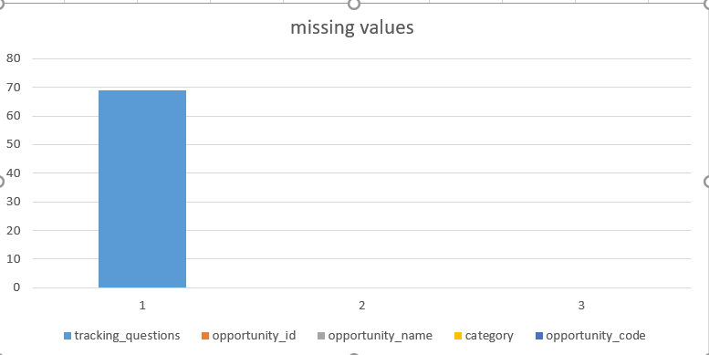

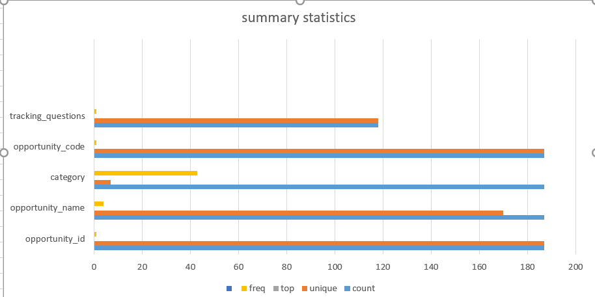

Exploratory Data Analysis Report

Dataset: CohortRaw.csv
1. Overview
The CohortRaw.csv dataset contains 639 records across 5 attributes. It appears to capture details of defined cohorts, including identifiers, lifecycle dates, and cohort sizes. All fields are complete, and the dataset contains no duplicate records.
Summary Statistics:
Rows: 639
Columns: 5
Categorical Variables: 2 (cohort_id, cohort_code)
Numeric Variables: 3 (start_date, end_date, size)
Datetime Variables: 0 (date fields stored as numeric timestamps)
Primary Key Candidate: cohort_code (unique across all rows)

2. Field-Level Assessment
Field | Data Type | Non-Null Count | Missing % | Unique Values | Observations
cohort_id | object | 639 | 0.00% | 1 | Constant value (“Cohort#”), not suitable as a unique key.
cohort_code | object | 639 | 0.00% | 639 | Each cohort_code is unique; can serve as a primary identifier.
start_date | float64 | 639 | 0.00% | 263 | Stored as epoch milliseconds; requires conversion to datetime.
end_date | float64 | 639 | 0.00% | 275 | Stored as epoch milliseconds; requires conversion to datetime.
size | int64 | 639 | 0.00% | 53 | Ranges from 1,000 to 100,000; potential for meaningful segmentation.

3. Data Integrity and Completeness
- Missing Values: None detected across all attributes.
- Duplicate Records: Zero duplicate rows identified.
- Key Integrity: cohort_code is unique for all records; cohort_id lacks variability.
- Consistency: Numeric and categorical fields show no format violations.

4. Descriptive Insights
- Cohort Size Variation: Cohort sizes are unevenly distributed, suggesting the existence of both small, niche cohorts and significantly larger groups.
- Date Fields: start_date and end_date indicate diverse cohort durations and possible overlaps; these need to be converted from epoch time for temporal analysis.
- Lifecycle Overlaps: Given multiple identical start and end dates across records, concurrent cohorts are likely active in the same timeframes.

5.Visualizations

1.Distribution of Cohort Sizes in CohortRaw Dataset

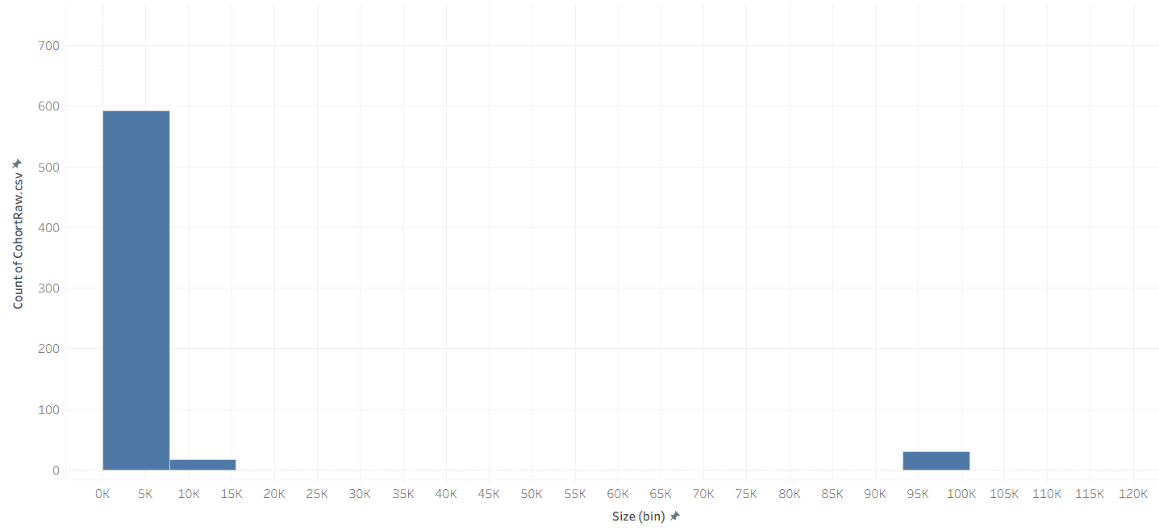

2.Yearly Start and End Timelines for Cohorts

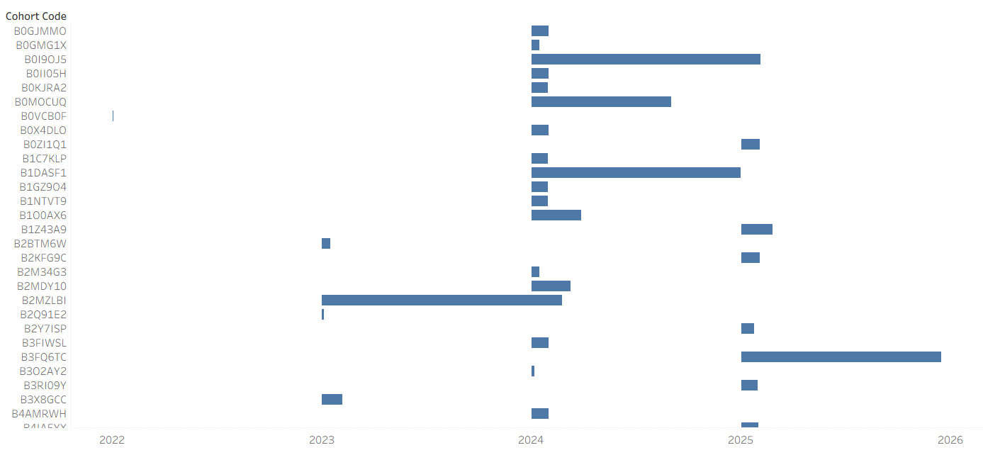

3.Largest Cohorts by Size (Descending Order)
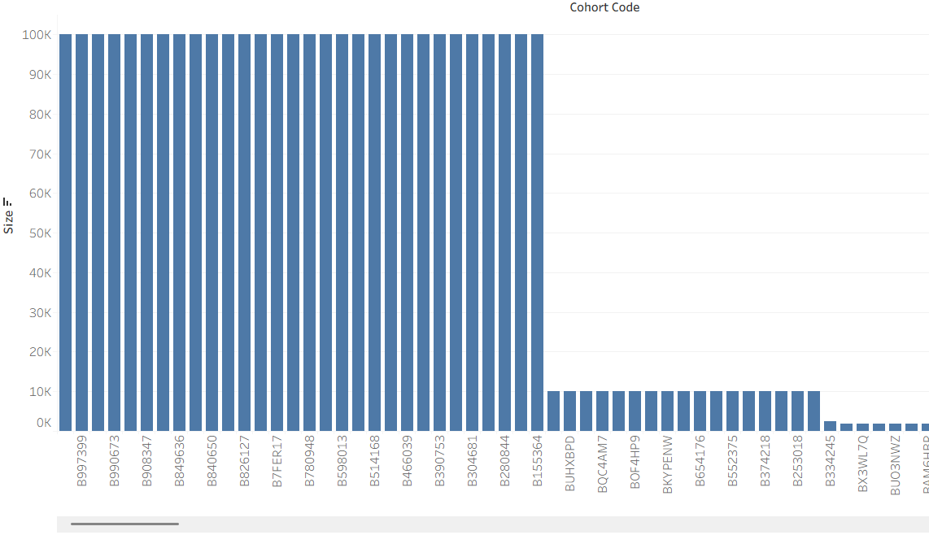

4.Weekly Distribution of Cohort Start Dates by Weekday
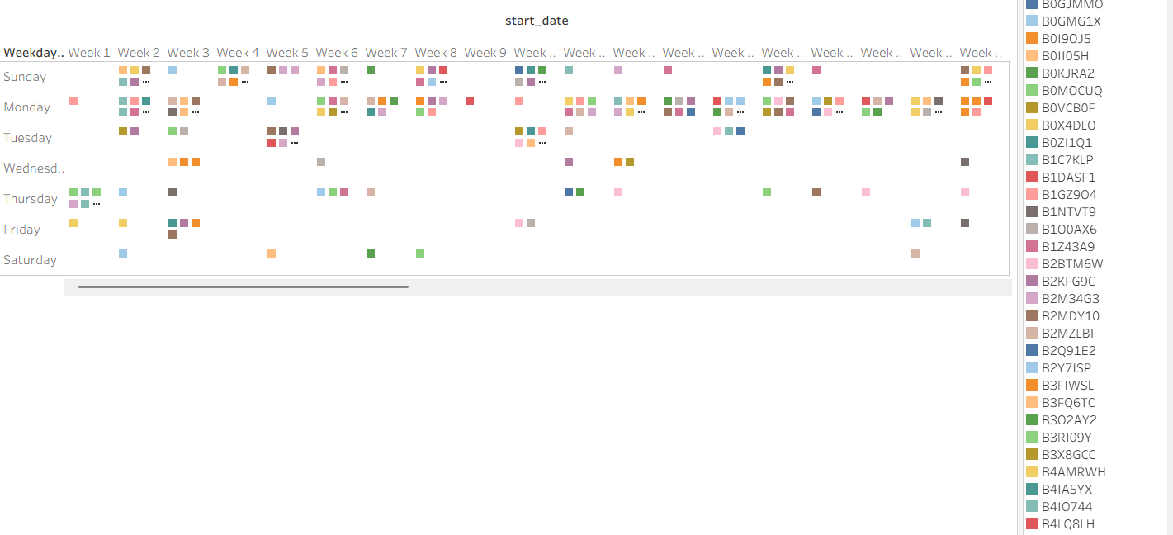

5. Monthly Start and End Timelines for Cohorts

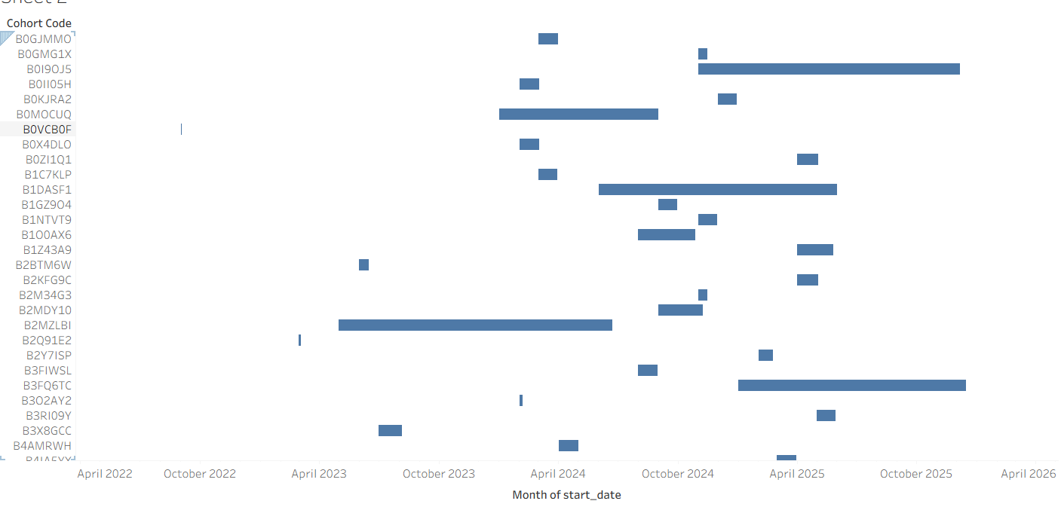

EDA Report (market_data_1)

Objective
Perform exploratory analysis to summarise dataset characteristics and highlight immediate insights that will guide Week 2 cleaning and transformation.

1. Dataset overview (quick)
- Table: market_data_1
- Rows: 149
- Columns: 13
- Sample preview: include a screenshot of first 10 rows from your query SELECT * FROM market_data_1 LIMIT 10; (paste into the report document in your editor).

2. Summary statistics (key metrics)
- Reach: min = 0, max = 141,835,342, avg = 1,702,121.09
- Outbound clicks: min = 14, max = 38,284, avg = 3,683.20
- Results: min = 1, max = 142,000,000, avg = 1,288,932.64
- Amount spent (AED): min = 0.99, max = 25,531.47, avg = 2,399.96
(These numbers are calculated on the raw imported data - document them as-is and indicate that cleaning may change them.)

3. Data quality summary
- Missing values (per column) - recorded during EDA (paste counts): many columns have 7–10 missing entries each; dates has ~8 missing/invalid entries.
- Duplicates: 12 duplicate rows detected when checking Campaign name + dates.

4. Key findings (top-level insights)
- Top campaigns by clicks: examples from the dataset (top 5):
  - CPR - March Ads: Website Leads Prospecting | 1 - 38,284 clicks
  - March Brand Awareness - 32,289 clicks
  - JAN. INTERNSHIP: Virtual Internship - 27,483 clicks
  - Project Management Associate Intern - 22,219 clicks
  - Data Analyst Associate Intern - 21,464 clicks
- Best cost per result (campaign-level): campaigns with lowest cost-per-result values are brand-awareness style campaigns (very low cost-per-result values in the raw data). Note: extremely small cost-per-result values may be a sign of rounding or unit mismatch - investigate in Week 2.

5. Visualisation (what to include)
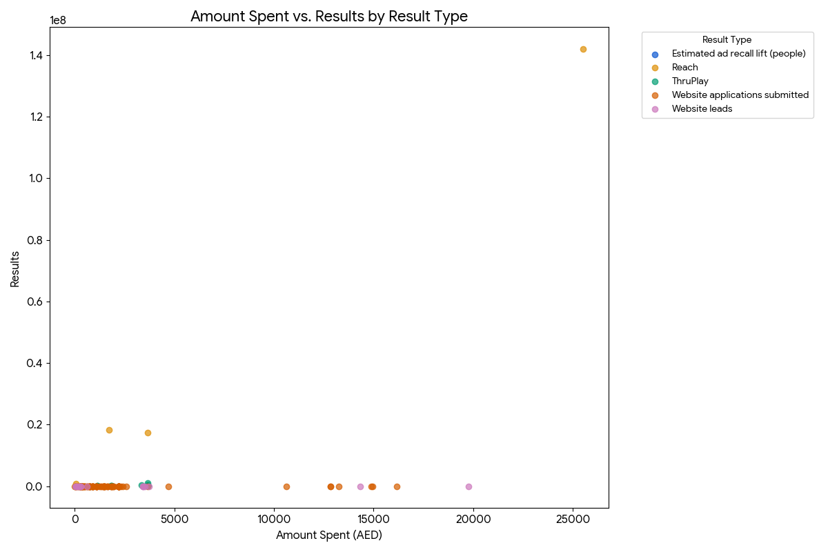
Amount Spent vs. Results by Result Type
This scatter plot visualizes the relationship between a campaign's total spending and the number of results it generated. The data points are color-coded by Result type to help identify unique spending and performance patterns. The chart shows that campaigns with higher spending do not always produce the most results, and that different campaign objectives have distinct spending and results profiles.

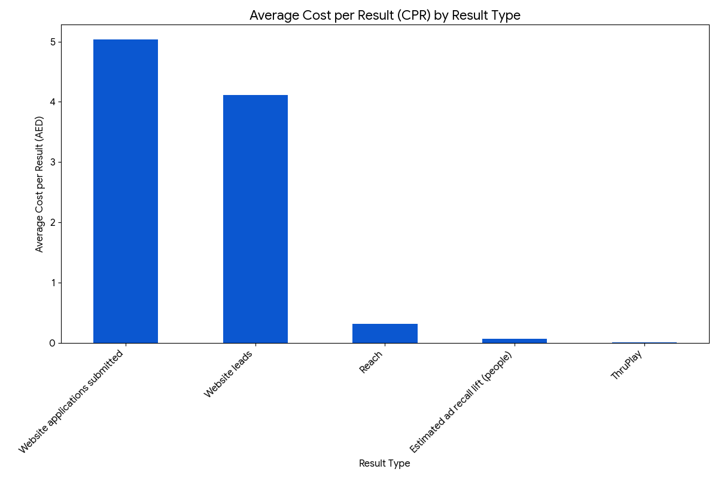

Average Cost per Result (CPR) by Result Type

This chart compares the average cost to achieve a single result for different campaign goals. It clearly shows that campaigns with high-intent results like Website leads and Website applications submitted have a much higher average Cost per Result than campaigns focused on brand awareness metrics like ThruPlay and Reach.

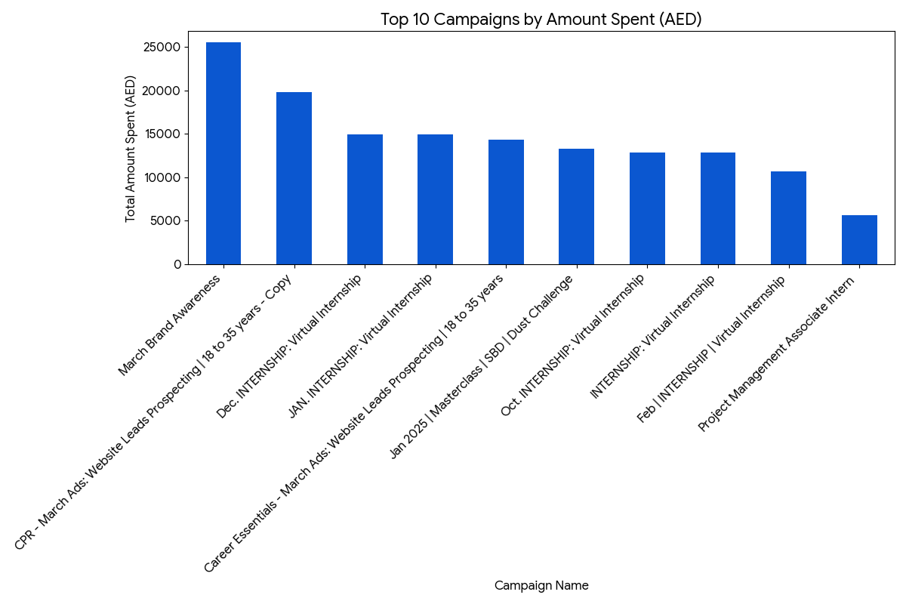

Top 10 Campaigns by Amount Spent (AED)
This bar chart highlights the campaigns that had the highest total spending. The March Brand Awareness campaign is an exceptional outlier, having an enormous budget compared to all other campaigns. This visualization is crucial for understanding where marketing resources were heavily concentrated.

6. Recommendations / Next steps (Week 2)
- Clean dates: parse valid date formats, set invalid values to NULL or correct where possible. Create a campaign_date DATE column and standardise formats.
- Handle missing values: decide imputation or removal strategy per column.
- Resolve duplicates: deduplicate by campaign + date or investigate duplicates if they are legitimate repeated runs.
- Unit & scale checks: verify cost and result units (some cost-per-result values are extremely small). Confirm with data owner if needed.
- Merge: after cleaning, merge marketing data with user/cohort tables to analyze conversion funnels and ROI by campaign.

“LEARNER OPPORTUNITY DATASET”
1. UNDERSTANDING DATASET AND STRUCTURE
The dataset contains information on learner opportunities, including key attributes such as (Enrollment_id, Learner_id, Assigned_cohort, Apply_date, Status) . The dataset appears to track learner enrollment information within a training or educational program. Each record links a learner (learner_id) to an enrollment instance (enroll_id), along with their assigned cohort, apply date, and status. Each row represents a unique opportunity entry, while the columns capture descriptive, categorical, and numerical information related to the learners and their opportunities.
2. DATASET OVERVIEW
- Rows: 113602 rows
- Columns: 5
- Potential key columns: enrollment_id , learner_id
- Missing values:
- assigned_cohort: 13318 missing values
- apply_date: 188 missing values
- status: 186 missing values
- Duplicate values: 0
1.COLUMN NAMES AND MEANINGS
Column Name and Meanings | DataType
Enroll_id – Unique enrollment record ID. | Text
Learner_id – Unique learner identifier. | Text
Assigned_cohort – Cohort/group allocation for the learner. | Text
Apply_date – Application submission date. | Text
Status – Enrollment status code or label. | Integer

2,RELATIONSHIPS BETWEEN THEM
- Learner_id → enroll_id : 1 : n (one learner can have multiple enrollments)
- Enroll_id → apply_date : 1 : 1 (each enrollment has one application date)
- Enroll_id → status : 1 : 1 (each enrollment has one status)
- Enroll_id → assigned_cohort : 1 : 1 (each enrollment is linked to one cohort)
Total number of records (rows) : 113602 rows
3. SUMMARY STATISTICS
A statistical overview of key numerical attributes was generated to understand central tendencies and distribution. Metrics include:
- Total Values: 113416
- Mean: 1068.1924
- Median: 1070
- Minimum: 1010
- Maximum: 1120
- Standard Deviation: 21.0274
4. DATA QUALITY ASSESSMENT
1. MISSING RECORDS
The dataset was examined for missing (NULL) values . The results indicate that the first two columns (enroll_id, learner_id) have no missing values.
However, the last three columns — assigned_cohort, apply_date and status— contain missing entries.
- Assigned_cohort: 13318 missing values
- Apply_date: 188 missing values
- Status: 186 missing values
These missing records may impact downstream analysis and will require either imputation or removal, depending on the analytical requirements.
2. DUPLICTAE RECORDS
Duplicate checks were performed using PostgreSQL. The results show that no exact duplicate rows exist in the dataset (duplicate row count = 0).
5. OUTLIER AND ANOMALY DETECTION
To detect outliers in numeric columns (e.g. status),the IQR method was used.
- Q1 and Q3 were calculated using PERCENTILE_CONT()
- Values outside Q1 - 1.5*IQR and Q3 + 1.5*IQR were identified as outliers.
- X number of outliers were found.
Status column contains integer values . So we applied the Interquartile Range (IQR) method to the status column to identify potential outliers.
Metric | Value
Q1 (25%) | 1070
Q3 (75%) | 1170
IQR (Q3 − Q1) | 0
Outliers Found | 0
Q1 (25th percentile) and Q3 (75th percentile) were both 1070, resulting in an IQR of 0.
As there is no variation in the data, the calculated lower and upper bounds are both 1070, indicating there are no statistical outliers in this column. No such values were found, indicating that the status values do not contain outliers.
6. DATA VISUALIZATION INSIGHTS
- Histogram:
Analysis of Status and Frequency (Histogram)
The histogram reveals that values near 1030, 1060, and 1120 occur much more frequently than others. This relationship highlights that the dataset is not uniformly distributed but instead clustered around these key points.
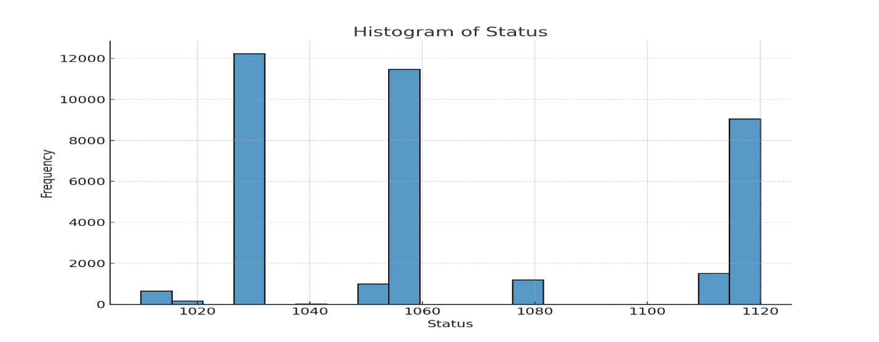
- Line Chart:
Analysis of Status Over Records (Line Chart)
The line chart shows application trends over time, highlighting peaks on certain dates.
There is visible variation in the number of applications.
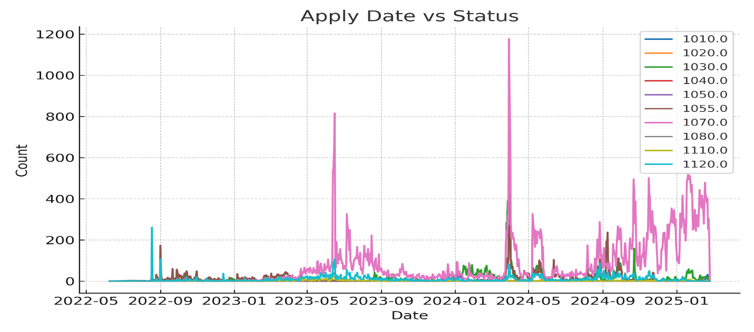
- Box Plot:
Analysis of Status (Box Plot)
The box plot indicates that the “status” values are spread between roughly 1010 and 1120, with the median around 1055–1060. The symmetrical whiskers suggest a balanced distribution without extreme outliers. This relationship shows that the data’s spread and central tendency are stable.
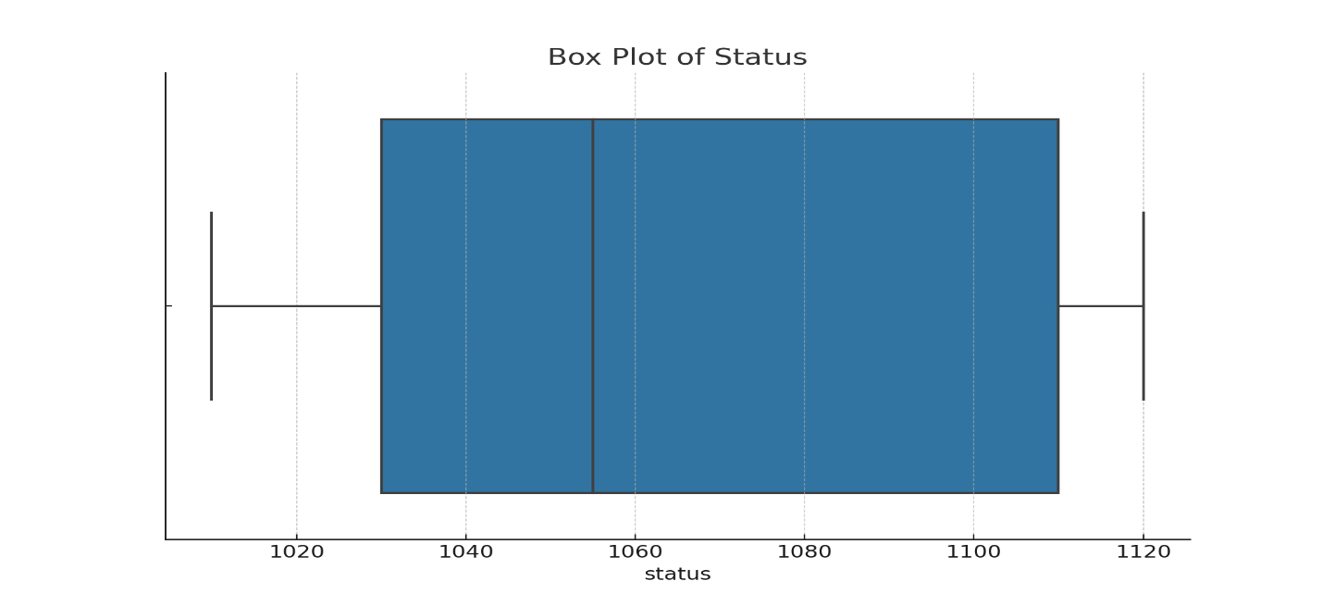
7.EXPLORATORY DATA ANALYSIS (EDA) SUMMARY
An initial assessment of the dataset was conducted, reviewing column names, data types, and the total number of observations. Data quality checks were performed to identify missing values and duplicate records. For numerical variables, measures of central tendency (mean, median, standard deviation). Outliers and inconsistencies were detected using both summary statistics and visualizations. These steps provide a strong foundation for subsequent data cleaning and further analysis.

Exploratory Data Analysis Report

1) Dataset Overview
- Rows: 129178
- Columns: 9
- Numeric: 0 | Categorical: 7 | Datetime: 2
- Potential key columns: user_id, email, UserCreateDate, UserLastModifiedDate
- Exact duplicate rows (excluding first occurrence): 0
- Rows appearing more than once (all duplicates counted): 0

Schema Snapshot (first 200)
column | dtype | non_null | nulls | null_% | unique_values | sample_values
user_id | object | 129178 | 0 | 0.0 | 129178 | 00010567-1336-433c-a941-a612b3d2fbb8; aab8bd87-af83-4e21-816b-101cf05f9a79; 4656095f-a932-4889-ae96-3b77ff60f1e4
email | object | 129178 | 0 | 0.0 | 129169 | gikonyosalome19@gmail.com; evelyn.natasha.guo@gmail.com; lauren.singh@rocketmail.com
gender | object | 86316 | 42862 | 33.18 | 4 | Female; Male; Other
UserCreateDate | datetime64[ns, UTC] | 129178 | 0 | 0.0 | 127424 | 2024-11-17 21:25:56.381000+00:00; 2025-01-19 02:07:06.113000+00:00; 2024-03-26 23:23:54.329000+00:00
UserLastModifiedDate | datetime64[ns, UTC] | 129178 | 0 | 0.0 | 129177 | 2024-11-17 21:32:50.783000+00:00; 2025-01-19 02:07:20.726000+00:00; 2024-09-27 13:47:51.806000+00:00
birthdate | object | 86316 | 42862 | 33.18 | 9729 | 5/4/1996; 4/5/1990; 12/28/1998
city | object | 86312 | 42866 | 33.18 | 13431 | NAIVASHA; Queens Village; Ibadan
zip | object | 86309 | 42869 | 33.19 | 20376 | 20117; 11428; 200221
state | object | 86241 | 42937 | 33.24 | 6175 | NAKURU; NY; Oyo

3) Categorical Summary
index | count | unique | top | freq | missing_%
user_id | 129178 | 129178 | 00004f18-8b86-4fe4-ad7e-6c8d988f5335 | 1 | 0.0
email | 129178 | 129169 | amaji5295@gmail.com | 2 | 0.0
gender | 86316 | 4 | Male | 49344 | 33.18057254331233
birthdate | 86316 | 9729 | 1/1/2000 | 115 | 33.18057254331233
city | 86312 | 13431 | Lagos | 3031 | 33.18366904581275
zip | 86309 | 20376 | 233 | 2646 | 33.18599142268807
state | 86241 | 6175 | Lagos | 6154 | 33.23863196519532

4) Missing Values by Column (Top 100)
column | nulls | null_%
state | 42937 | 33.24
zip | 42869 | 33.19
gender | 42862 | 33.18
birthdate | 42862 | 33.18
city | 42866 | 33.18
user_id | 0 | 0.0
email | 0 | 0.0
UserCreateDate | 0 | 0.0
UserLastModifiedDate | 0 | 0.0

5) Visualizations
Missing Values per Column
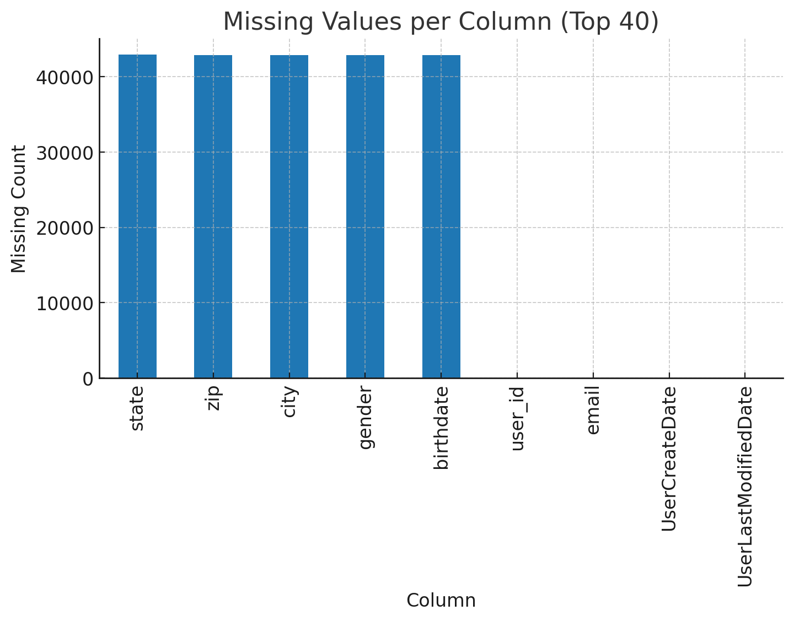

V3 BAR GENDER
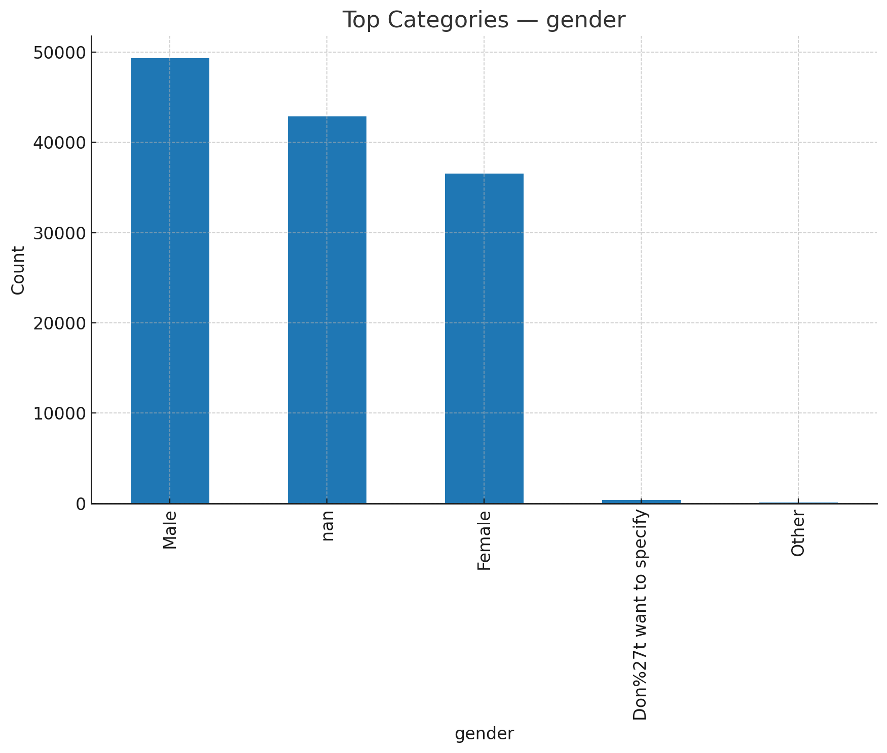

V3 DOW USERCREATEDATE
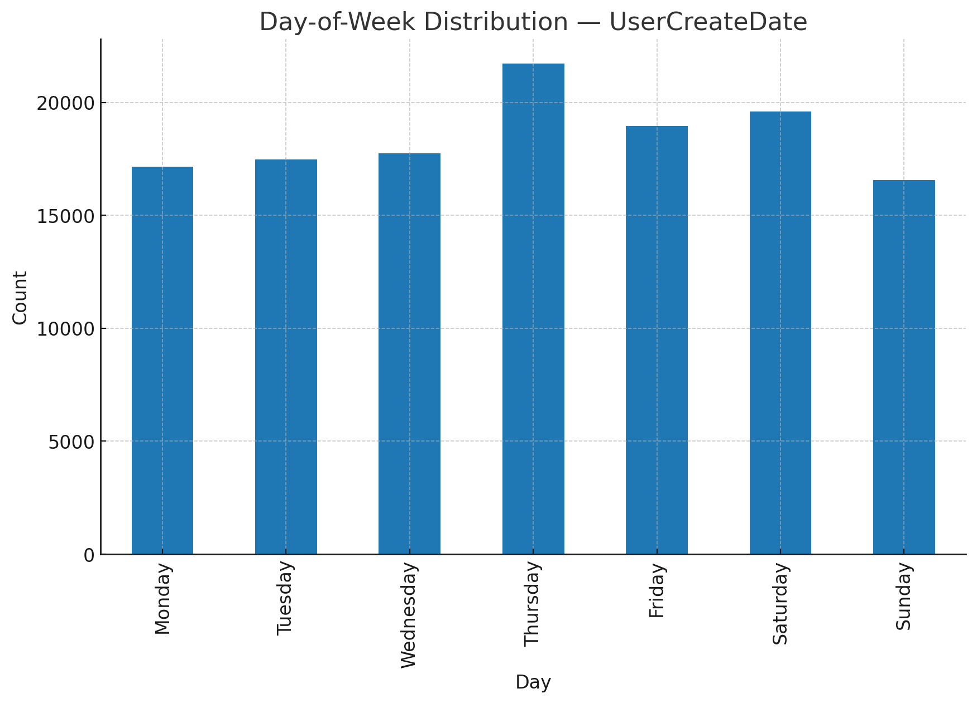

V3 HOUR USERCREATEDATE
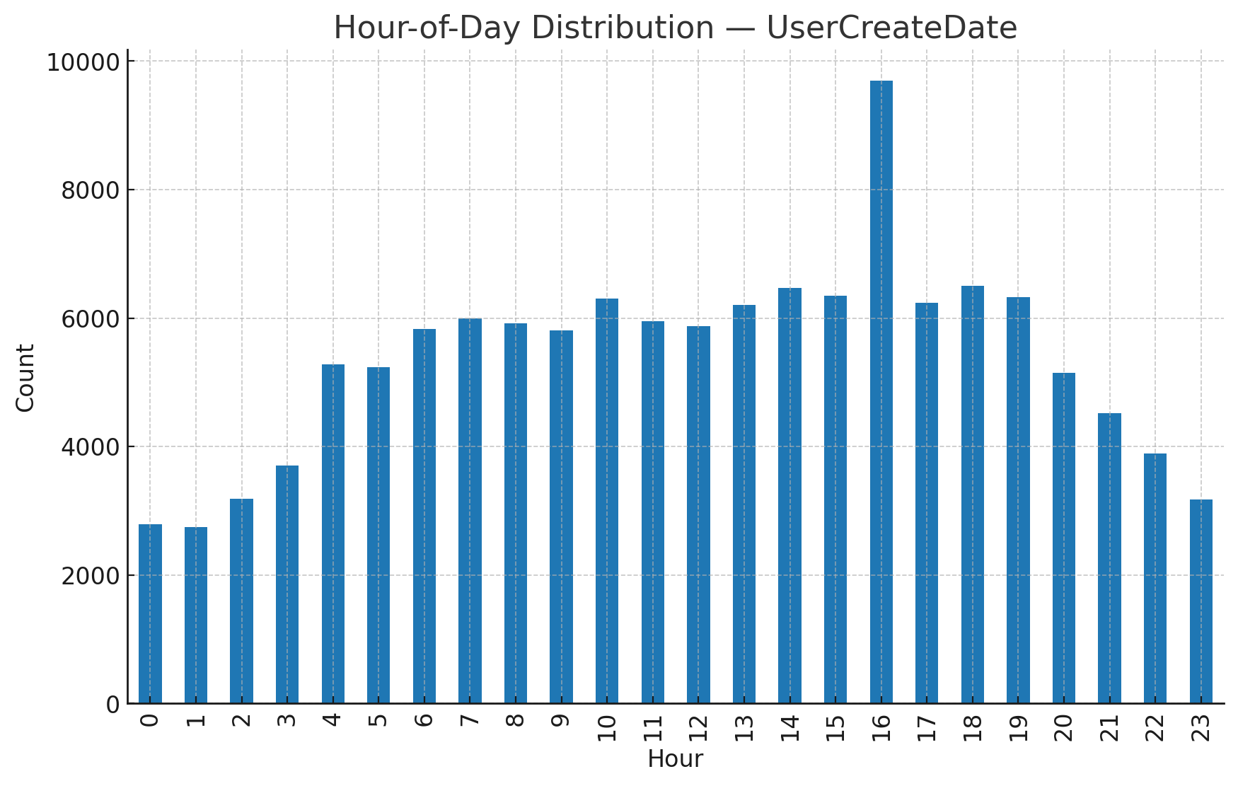
V3 TS MONTHLY USERCREATEDATE
